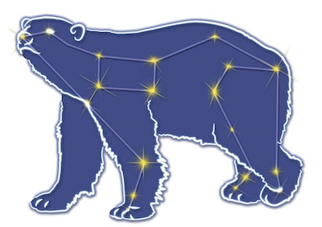
Great Bear Petroleum Operating LLC
A New Direction for the Last Frontier
601 W. 5th Ave., Suite 505, Anchorage, AK 99501
Phone: (907) 868-8070, Fax: (907) 868-3887

July 6, 2011

Ms. Cathy Foerster, Chair
Alaska Oil and Gas Conservation Commission
601 West 5th Ave., Suite 505
Anchorage, Alaska 99501

RE: Weekly Report of Operations
Great Bear Petroleum: Alcor #1 (PTD # 212-057)

Dear: Ms. Foerster,
This is a report of Great Bear Petroleum’s well operations on the Alcor #1 for the period June 29 through July 5, 2012, inclusive.

June 29, 2012 5,042’ MW 9.6 ppg Vis 77 sec Incl 0.62˚
Drill 8-1/2” hole 3,989’ to 5,042’. Hole taking 12 bbls mud while drilling each stand then giving it back on connections. No net losses. Begin planned wiper trip.

June 30, 2012 5,998’ MW 9.9 ppg Vis 77 sec Incl 0.51˚
Finish wiper trip to 3,510’ then back to bottom. No drag – hole in good condition. Drill 5,042’ to 5,998’ while slowly increasing mud weight to 9.9 ppg. Hole still breathing. Now taking/giving back 25 bbls per stand due to increased flow rate being used. Begin planned wiper trip.

July 1, 2012 6,365’ MW 10.0 ppg Vis 76 sec Incl 0.53˚
Short trip up to 4,946’ then back to bottom. Hole in good shape. Drill 5,998’ to 6,362’. Lost circulation. Pull up to 6,238’, mix and pump a 40 ppb LCM pill. No discernable effect. Mix and pump 38 bbls of 100 ppb LCM pill (coarser material) through circulating sub above BHA. No effect. Mix and displace from pits into DP 40 bbls of 100 ppb LCM pill (very coarse material).

July 2, 2012 6,365’ MW 10.0 ppg Vis 78 sec Incl 0.53˚
Mix add’l 40 bbls of LCM pill to make a total of 80 bbls to be pumped away. Displace LCM pill out circ sub in BHA, PU from 6,360’ to 5,800’ and circulate. Returns at 40-50%, no static losses. RIH to 6,189’ and mix 30 bbls gunk pill (Halliburton Geltone V + Barazan D). Displace to thief zone and squeeze away 27 of the 30 bbls pumped. POH to 5,806’ and monitor well while waiting for gunk squeeze to set.

July 3, 2012 6,365’ MW 10.0 ppg Vis 78 sec Incl 0.53˚
Wait for gunk squeeze to set. C&C hole – stable. POH, LD BHA, service top drive, prepare to test BOPs.

July 4, 2012 6,365’ MW 9.7 ppg Vis 75 sec Incl 0.53˚
Test BOPE – test witness waived by AOGCC’s John Crisp. MU BHA #3 and RIH to surface casing shoe. Cut & slip drilling line, repair top drive.

July 5, 2012 6,434’ MW 9.7 ppg Vis 78 sec Incl 0.44˚
Repair top drive. RIH to 5,908’. Reduce mud weight to 9.7 ppg. Wash & ream to btm at 6,365’. Drill 8-1/2” hole 6,365’ to 6,434’, experienced severe lost circ. Open circ sub and spot LCM pill. POH to 5,908’and circ. Hole stable.

If you have any questions or require additional information, please contact me at 264-6114 or 250-3113.

Sincerely,

For GREAT BEAR PETROLEUM OPERATING LLC

Bill Penrose

Drilling Manager
SolstenXP Inc.

cc: Clark Clement – Great Bear

